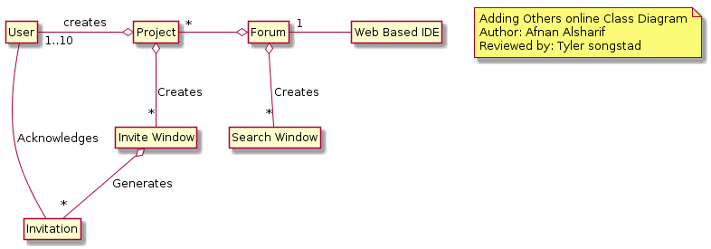

@startuml

hide circle

hide empty method

hide empty fields

note "Adding Others online Class Diagram\nAuthor: Afnan Alsharif\nReviewed by: Tyler songstad" as Nhue

class “Web Based IDE”

class User

class “Invite Window”

class Forum

“Web Based IDE” -Left- "1" Forum

Project o-Left- "1..10" User : creates

hide circle

hide empty methods

hide empty fields

Project o-Down- "\*" “Invite Window”: Creates

“Invite Window” o-- "\*" Invitation: Generates

Forum o--"\*" “Search Window”: Creates

Forum o-Left-"\*" Project

Invitation -- User: Acknowledges

@enduml